FAMILY TRACKING APP USING GPS

MINI PROJECT REPORT

Submitted by

P.BHARATHI REG.NO:19TH0411

R.GAJALAKSHMI REG.NO:19TH0422

S.JAYAPRIYA REG.NO:19TH0431

In partial fulfillment of the requirement for the degree of

BACHELOR OF TECHNOLOGY

in
INFORMATION TECHNOLOGY


of

PONDICHERRY UNIVERSITY

DEPARTMENT OF INFORMATION TECHNOLOGY

MANAKULA VINAYAGAR INSTITUTE OF TECHNOLOGY

KALITHEERTHALKUPPAM, PUDUCHERRY- 605 107.

JULY - 2022

MANAKULA VINAYAGAR INSTITUTE OF TECHNOLOGY DEPARTMENT OF INFORMATION TECHNOLOGY

BONAFIDE CERTIFICATE

This is to certify that the Mini Project Work titled “FAMILY TRACKING APP USING GPS” is a Bonafide work done by BHARATHI.P [Reg. No. 19TH0411], GAJALAKSHMI.R [Reg. No.19TH0422], and S.JAYAPRIYA [Reg.No.19TH0431] in partial fulfillment for the award of the degree of Bachelor of Technology in Information Technology of the Pondicherry University during the academic year 2021-2022.

Staff in charge Head of the Department
(Dr.A.MEIAPPANE) (Dr.P.SIVAKUMAR)

Submitted for the University Examination held on.............................

INTERNAL EXAMINER EXTERNAL EXAMINER

ACKNOWLEDGEMENT

We express our deep sense of gratitude to Theiva Thiru. N. Kesavan, Founder, Shri. M. Dhanasekaran, Chairman & Managing Director, Shri. S. V. Sugumaran, Vice-Chairman and Dr. K. Narayanasamy Secretary of Sri Manakula Vinayagar Educational Trust, Puducherry for providing necessary facilities to successfully complete our mini project and report works.
We express our sincere thanks to our beloved Principal Dr. S. Malarkkan for having provided necessary facilities and encouragement for successful completion of this project work.
We express our sincere thanks to Dr. P.Sivakumar, Head of the Department, Department of Information Technology, for his support in making necessary arrangements for the conduction of Project and also for guiding us to execute our project successfully.
We express our sincere thanks to Dr. A. Meiappane, Professor, Department of Information Technology for his consistent reviews which motivated us in completing project.
We thank all our department faculty members, non-teaching staffs and my friends for helping us to complete the document successfully on time.
We would like to express our eternal gratitude to our parents for the sacrifices they made for educating and preparing us for our future and their everlasting love and support.
We thank the Almighty for blessing us with such wonderful people and for being with us always.

P.BHARATHI
R.GAJALAKSHMI
S.JAYAPRIYA

ABSTRACT

The project that is dearly suggested is real-time family tracking by using GPS application and with the change in human living standards, a human needs to travel alone at new places. He is not aware of various places at new location. His family members might be worried about his well-being.
We have developed an Android based Real-Time Family tracking App which is able to track current location of a person. It will inform a person about his current location at regular interval of time. We have also developed a database in which a user can save information about his E-mail and Name and this information can be hand over to a person who is interested in travelling at same place.
This App is able to register new people and it is able to provide Login facility at any instance of time. This application makes use of real time Firebase database.
The importance of this application is to get touch with your loved ones and keep them in contact.

TABLE OF CONTENTS
ACKNOWLEDGEMENT iii
ABSTRACT iv
TABLE OF CONTENTS V
- INTRODUCTION
  - Existing System 1
  - Proposed System 1
- REQUIREMENTS 2
  - Hardware Requirements 2
  - Software Requirements 2
- MODULE DESCRIPTION 3
- DESIGN 4
  - Use case Diagram 20
  - Class Diagram 21
  - Activity Diagram 23
  - Sequence Diagram 24
  - Collaboration Diagram 25
  - Data dictionary 26
- CODING 27
- TESTING 51
- OUTPUT SCREENS 53
- CONCLUSION 63
REFERENCES 64
APPENDIX 65

1. INTRODUCTION

The project named Family tracker is a mobile application which is designed to track the location of other people in real-time. The user will create or join the existing group with a unique code provided to them and with that code they all will get connected to each. Our mobile application will work on android platform and for that user’s network connection and GPS should be enabled.
If the user’s network connection is not available then the app will show the last location of the user before the user turns off his/her mobile network connection.
  - EXISTING SYSTEM
The existing app contains only one user to access and track the location. It involves the join code and create code .Through the unique code the child can join the code. And the parent can track the location of the child.
  - PROPOSED SYSTEM
Our proposed system will be able get access to all the users .For example, User 1 can create the circle with the unique code and the specific code is shared to all the users. Our app is so user friendly and ease to use. GPS system is also used in our app. So this proposed system overcomes the drawbacks faced int the existing system.

2. REQUIREMENTS

2.1 HARWARE SPECIFICATIONS

- Processor : Intel(R) Core(TM) i5.
- Memory (RAM) : 8.00 GB.
- Hard Disk :1tb
- System type : 64-bit Operating System.
- Android Mobile : Android Lollipop

2.2 SOFTWARE SPECIFICATIONS

- Toolkit : Android Studio IDE.
- Front End : JAVA , Extensible Markup Language(XML).
- Back End : Google Firebase.

3. MODULES

    - MODULE 1: REGISTRATION
    - MODULE 2: LOGIN PAGE
    - MODULE 3: CREATE CIRCLE
    - MODULE 4: JOIN CIRCLE
    - MODULE 5: GET LOCATION

REGISTRATION
This page is used to register the information of the user for the respective Location. It includes the E-mail id, Mobile no, Password and Confirm Password. When the Submit button is clicked all the user details are stored in Database with Permission.

LOGIN
In this page it contains username and password. If the user is an existing user , then they should enter the username and password. If the given username and password are correctly they are directed to main page. If the password and username is incorrect, it shows a message as “Invalid Username and Password”. If the customer is new they must create new account.

CREATE CIRCLE
If the user wants to create a circle, the user has to send the unique code(six digit code) to the circle members that is being generated by the system.

JOIN CIRCLE
By using six digit code, the circle members can join the group easily.

GET LOCATION
After these procedures, the users can locate their friends and family with the help of GPS services very easily.

4. DESIGN

UNIFIED MODELING LANGUAGE:
The heart of the object oriented problem solving is the connection of a model. The model abstracts the eventual details of the underlying problem from its detail of the underlying usually complicated real world. Several modelling tools are wrapped under the heading of the UML, which stands for unified modelling language. The purpose of the course is to present important highlights of the UML.
      - Use case diagram
      - Class diagram
      - Object diagram
      - Sequence diagram
      - Collaboration diagram
      - State chart diagram
      - Activity diagram
      - Component diagram
      - Deployment diagram
Some of the section of this course contains links to pages with more detailed information. And every section has start question. Use them for understanding of the section topic.

Why UML is important?
Let’s look at these questions from the point of view of the construction trade. Architect design building, builders of the design to create buildings. Builders use the design to create more complicated buildings the more

critical the communication between architect and builders. Blue print is the standard graphical language that both architects building must learn as part of this trade.Writing software is not unlike constructing a building, the more complicated underlying system, the more critical the communication among everyone involved in creating and developing the software.
In the part decade the UML has emerged as the software blueprint language for analyst, designers and programmers alike.
It is new part of software trade. The UML gives everyone from business analyst designer to program a common vocabulary to task about software design.
The UML is applicable to object oriented program solving. Anyone interested in learning UML must be familiar with the underlying text of object oriented problem. It all begins with construction of a model. A model is an abstraction of the underlying problem. The domain is the actual word from which the problem comes.
Models consist of object that interact by sending each other message think of an object as “alive” object have things, they know and things can be (behavior or operation). The value of the object attribute determines its state.

Classes are the blueprint for object. A class wraps attributes (data) and behavior (method or function) into a single distinct entity object are instances of class.

An introduction to UML diagram
The unified modeling language for specifying, constructing, visualizing and documenting the certificate of the software intensive system. Analogue to use of architectural blueprint in the construction industry.
UML provides a common language for describing software model and it can be use in conjunction with a wide range of software life cycle and development process.

Use case diagram
Use case diagram identify the function provided by the system. The user who interact with the system and the allocation between the user and the functionality. Use case is used and the analysis phase of software development to Particulate the high level requirements of the system. The primary goals of use case diagram include.

    - Providing a high level view of what the system does.
    - Identify the user (“actor”) of the system.
    - Determining areas needed human computer interfaces.
    - Use case extended beyond pictorial diagram.
    - In fact text bound use case description as often used to supplement
diagrams and the explore use case functionality in more detail.

GRAPHICAL NOTATION:
The basic component of use case diagram are actor. The use case and association.

ACTOR:
An actor, as mentioned is a user of the system and is depicted using a stick .
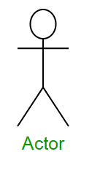

The role of use is written beneath the icon. Actors are not limited to humans. If a system communication with other application and except input or delivers output then that application can also be considered as actor.

USE CASE:
A use case is functionality provided by the system typically describe verb + object.
A Use case is a methodology used in system analysis to identify, clarify &
organize system requirements.

Example:
Register (car, delete user) use case is depicted with a ellipse. The name of the use case is written within the ellipse.

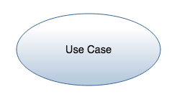

Association
It is used to link actor with the use cases and indicate that an actor participate in the some form. Association is depicted by the link connecting the actor and the user case.

The following image show how there three basic element work together to form a use case diagram.
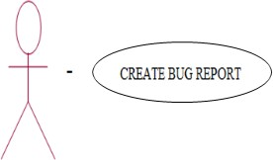

Use case diagram describe what a system form the standard stand point of an external observer. The emphasis is what system does rather than how.
A scenario is an example of what happen, when someone interact with the system. There is a scenario for a medical clinic.

“A patient calls the clinic to make an appointment for a yearly checkup. The receptionist find the nearest empty time slot in the appointment books and schedule the appointment for that time slot.
A use case is a summary of scenario for a single task or goals. An actor is who or what initiate the events involved are simply role that people object play.
The picture below is the make appointment use case for the medical clinic. The actor is a patient. The connection between actors and use case is a communication association.

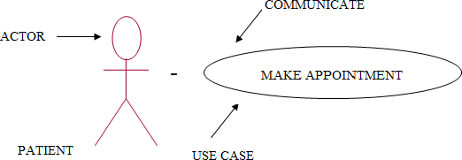

Actor are stick figure user case are over all communicate and line that a link actor to use case.
A use case diagram is a collection of actor use case and their communication; we must put make appointment as a part of diagram with 4 actor of 4 use cases. Notice that a single use case has multiple actors. Use case diagram are helpful in three areas.

Deterministic Features
New use case often generate a new request as the system is analyzed and the design that sequence.

Communicating with client
Their national simplicity makes use case diagram a good way those Sceneries.
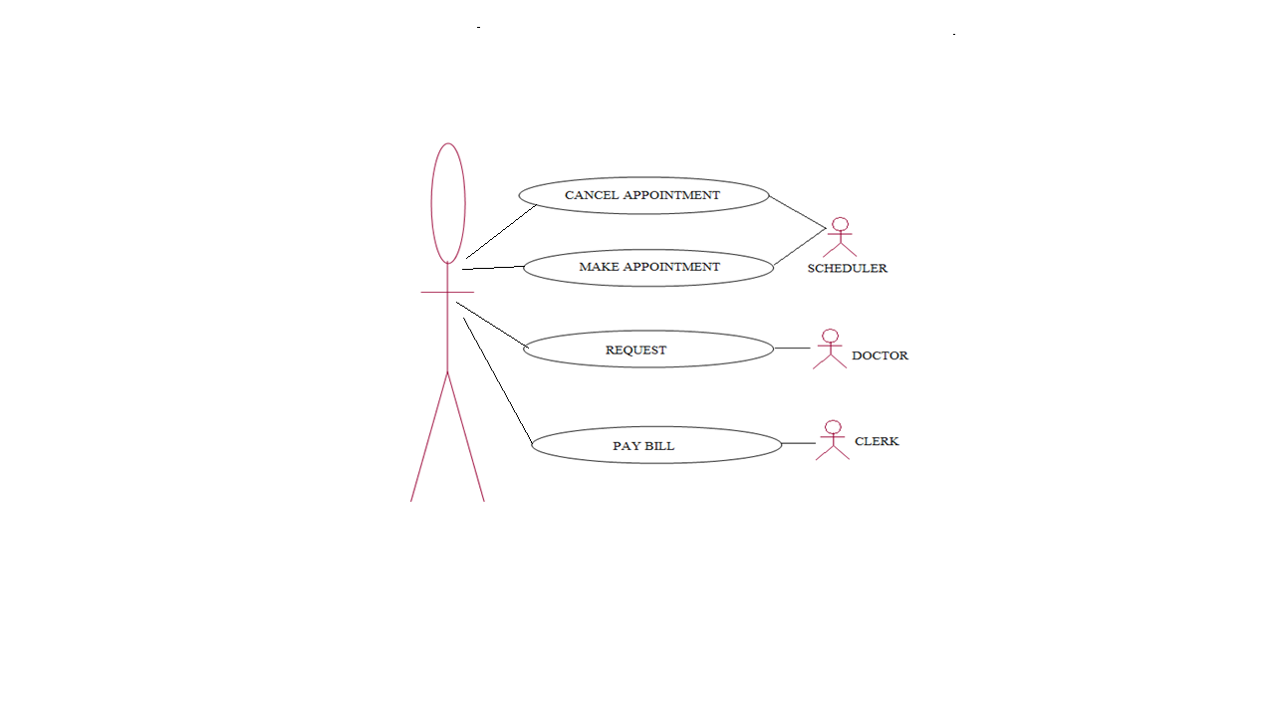

The collection of scenario for a use case may suggest a suite of test cases for those scenarios.

Sequence diagram
Sequence diagram document that interact between classes to achieve a result such a use case. Because UML is designated for OOP that communicate between classes are known as message.
The sequence diagram lists over time.object horizontally and time vertically and modally their message

Object
Objects are instance of classes are arranged horizontally. The representation for an object is a class (a rectangle) with name preferred by the object name (optional) and a semicolon.
: object

Actor
Actor can also communicate with object so two can be listed as a Column. An actor is modeled using the unambiguous symbol the stick figure.
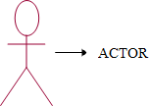
Life Time
The lifetime indicates the existences of the object overtime.The notation for the lifetime is a vertical dotted line extending from an object.
|
|
|
|

Activation
Activation modeled as a rectangular boxes on the lifetime, indicate when the object is performing an action.

Message
Message modeled as horizontal area between activation
Indicate the communication between the object.
Activity diagram
It is used to document workflow in a system, from the business level to operational level. When looking at an activity diagram, in fact the activity diagram is a variation of the state diagram. When the “states” represent operation and the transition represent the activities that happen when the operation is complete. The general purpose of a activity diagram is to flow on flow drive by internal processing Vs external extends.

Activity stages
Activity stages names as action by an object. The notations for these states are rounded rectangle, the same notation is found in state chart diagram.

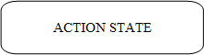

Transition
When an activity state is completed processing, moves to another state. Transitions are used to move this movement. Transitions are modeled using arrows.

Transition

Swim lane
It divide activities according to object by arranging object in column object are linked at the top of the column and vertical bars separate the column to form swim lanes.

Initial state
If marks the entry point and the initial activity state. The notation for the initial states in same as state chart diagrams a solid circle there an only be one initial state.

Final state
Final state mark the end of the modeled work-flow. These can be multiple final state on a diagram and those states are modeled using a said circle surrounded by another circle.

Synchronization bar
Activity of ten can be done is parallel to split processing(“bork”) or to resume processing multiple activities has been completed (“john”) synchronization bars are used these moduled as solids rectangles with multiple transition going in and or row.

A component diagram
Component diagram fall under the category of an implementation and diagram a kind of diagram that modules the implementation and development of the system. A component diagram is particular is used to describe the dependencies between exe files and source file. This information is similar to that within make files, which describes source code dependencies and can be used to properly compile an application.

Component
A component represents a software entity in a system. Eg, include source code files, program document and resource files. A component is represented using a rectangular box with two rectangle potential from the left side, as seeing the image to the right.

Dependency
Dependency is used to model the relationship between a component. The notation for the dependency relationship is a dotted arrow. Pointing from a component to depend
on.

Class diagram
A class diagram gives the over view of the system by showing its clauses and the relationships among them. Class diagram are static they display what interacts but not what happens when they do interact.

The class diagram below models a customer order from a detail category. The control class in the order. Associated with it are customer making in the purchase and payment is one of 3 kinds, cash, check or credit. The order contains the order detail (line, terms) each with its associated item.
UML class notation is a rectangle divided into three parts. Class name, attribute and operations.
Name of abstract clauses such as payment are in italics. Relationship between clauses are the connecting links.
Our class diagram has 3 kinds of relationship
- ASSOCIATION
- AGGREGATION
- GENERALIZATION

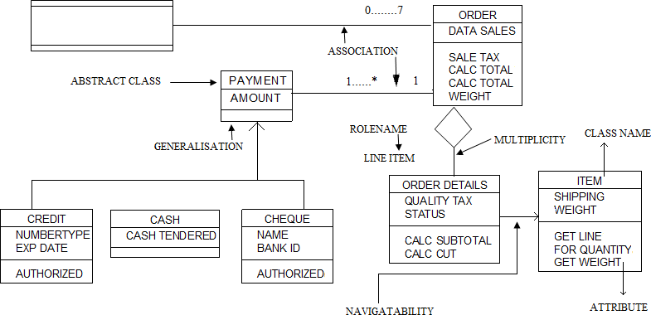

Association
A relationship between instances of a 2 clause. There is an association between two clauses. If and instance of one class must know about the other in order to perform the work. The diagram an association is a link connecting two clause.

Aggregation

An association in which one clause belong to a collection. An aggregation has a diamond end pointing to other part containing the whole. In our diagram, order as a collection of order detail.

Generalizations
An inheritance link indicating one clause is a super class of its other. A generalization has a pointing to the super class. Payment is a super class of cash, check and credit.
An association has two ends. An end may have role name to clarity the nature of association. For resemble an order detail is a line item of each other.
A navigability arrow on a association end is the no of possible instance of the class associated with a single instance of the class. Multiplicities are single number or range of number. In our resemble, there can be only one customer for each order but a customer can have any number of orders.

The table gives the most common multiplicities.

Multiplication | Meaning
0………1 | Zero or one instances. The notation n……n  indicates n to m instance.
0*… or* | No limit on the number by  instances(including name)
1* | Exactly one instances
1…..* | Atleast one instance

Every table class diagram has clauses, association and multiplicities. Navigability of roles are optional items placed in a diagram to provide a clarity.

Packages and object diagrams
To simplify the complexity classes diagram you can group class into package. A package is a collection of logically related UML element. The diagram below is a business model in which the clauses are grouped into packages.

Instance Name
Class Name
Math ID:Department
Applied Math:Department
Static:Department
Math:Department
Math State:Department
The hotel chain the send a make reservation message to the hotel. If the hotel has available rooms, then it makes a reservation and a confirmation.
Each rectangle in the object diagram corresponds to a single instance. Instance name are underlined in UML diagrams.
Class or instance names may be omitted from object diagrams as long as the diagram meaning is still clear.
Order
Shipping

Accounting |  |  | Bank

Package
Customer DB
Stock DB

Package appears as rectangle with small tasks at the top. The packages names is on the tab at inside the rectangle. The dotted arrows are dependent once package depends on one another if the changes.
This small class diagram show that a university department an contain lot of the other department.
The object diagram below instantiates the class diagram replacing it by a accurate example.

Sequence diagram
Class and object diagrams are static model views. Interaction diagram are dynamic.
They describe how object calibrate.

A sequence diagram is an interaction diagram that detail how operations are carried out. What messages are sent and when, sequence diagram are organized according to time. The time progress as you go drawn the page. The object is involved in the operations are listed from left to right occurring to when they take part in the message sequence.
Below is sequence diagram, for making Hotel reservation. The object initiating a sequence of message sequence.
Below the reservation window sends a make reservation () message to the Hotel chain in the data other could possibly force changes in the first.
Object diagrams shows instances instead of classes. They are useful for explaining small pieces with complicated relationship, especially recursive relationship.

Collaboration diagram
Collaboration diagram are also interaction diagram. They convey the same information as sequence diagram, but they forces an object roles instead of the timer, that message are send. In sequence diagram, object role are the vertices and message are connecting lines.
The object role rectangles are labeled with either class or object name (or both) class names are preceded by colons(:).
Each message in a collaboration diagram has a sequence number. The top-level message is numbered.
Message at the same level (send during the same cell) have the same decimal prefix but suffix of 1,2 etc according to when they occurs.

State chart diagram
Object has behavior and state. The state of the object depends on its current activity or condition. The state chart diagram shows the possible states of the object and the transactions that cause a change of state.
Our example diagram model the login part of an online banking system. Logging an consists of entering a valid solid security number and personal id ,number. Then submitting the information of validation.

Component and deployment diagrams
A component is a code module component diagram are physically analog of class diagram. Deployment diagram shows the physical configuration of s/w and hardware.
The following deployment diagram show the relationship among software and hardware components in real estate transition.
The physical hardware is made up of nodes. Each component belongs on a node.
Components are show as rectangle with two table at the upper left.

Real Estate Error
Listing
Mortage Appln
atabase ustomer db
D
c
Bank server

4. UML DIAGRAMS

4.1 USE CASE DIAGRAM

Description:

The main actors are the user 1 and the user 2. Both the user 1 and the user 2 can register and login to the app. The user 1 can share the unique code, update the user 2, and to join the user 2.The user 1 can view the location of user 2 and track their loved ones.
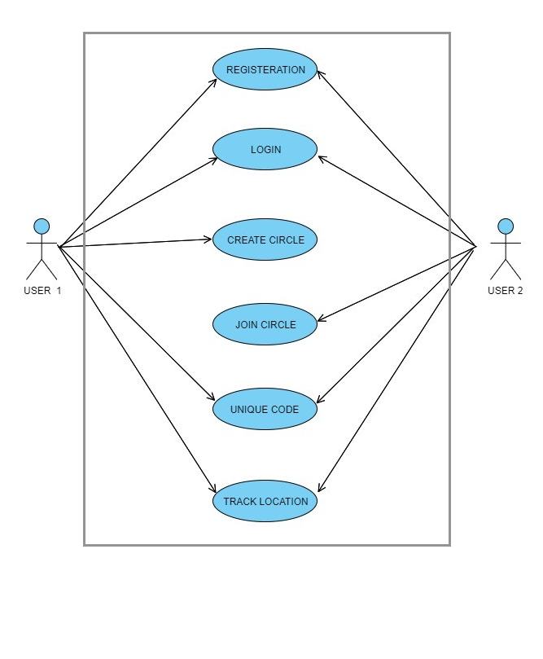

FIGURE: 4.1 USE CASE DIAGRAM

4.2 CLASS DIAGRAM

Description

The purpose of the diagram is to introduce some common terms and relationships between them. The class names are admin, register, home page, login, GPS (Global Positioning System). The Admin manages the login page and Register page is associated
with login and Home page is associated with Login. GPS is used to track the location of the user.

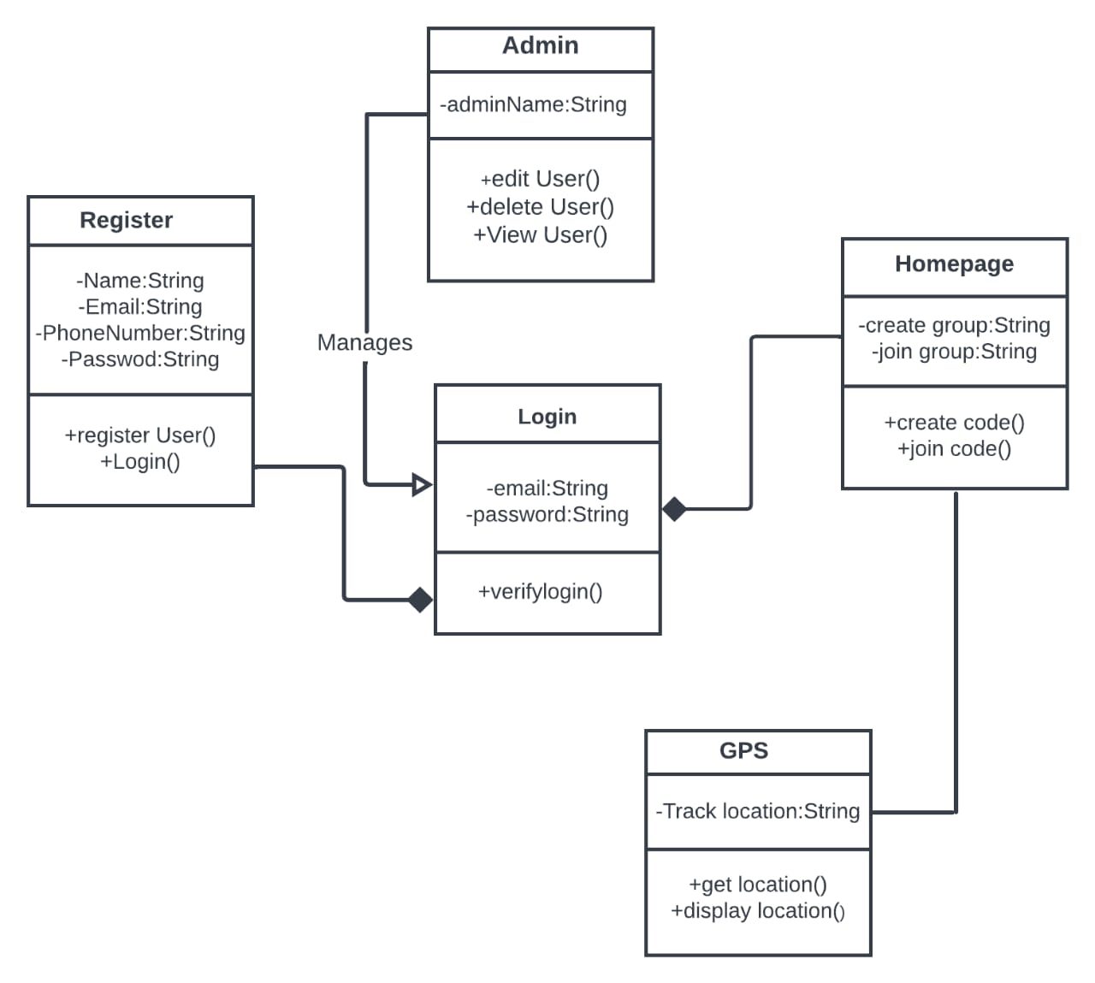

FIGURE : 4.2 CLASS DIAGRAM

4.3 ACTIVITY DIAGRAM:

4.3.1 REGISTERATION

Description:

If the user is new to the application then the user should register to the app first. Then the details are checked for corrections and verified. If the details are correct then the record will be saved otherwise it will be incompete and continued to the start page. If the user is successfully is registered it will give toast message. And it will go to the login page directly. After login it will go to home page.

FIGURE: 4.3.1 REGISTERATION

4.3.2 LOGIN
Description:
After the register page is successfully registered. Then the user can enter E-mail and password and submit the details. Then the details are verified if the details are correct it will give the toast message login successful but if the details are incorrect it will show some error messages.
FIGURE: 4.3.2 LOGIN

4.4 SEQUENCE DIAGRAM
Description:
There are three modules in the user, system and Database, these three modules are for login page and registration page. The details are checked by the system and the database. If the details are correct then the details are stored int the database and if the details are incorrect then the user must give the correct credentials.

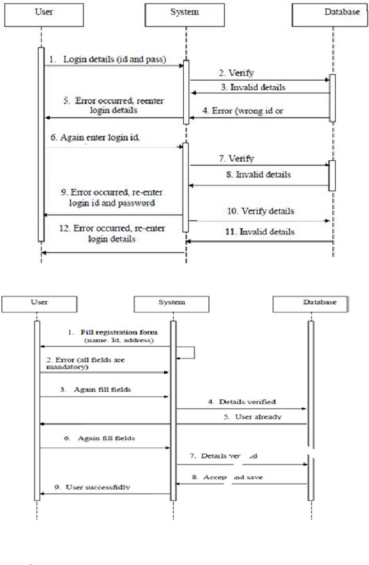
FIGURE: 4.4 SEQUENCE DIAGRAM

4.5 COLLABORATION DIAGRAM

4.5.1 REGISTRATION
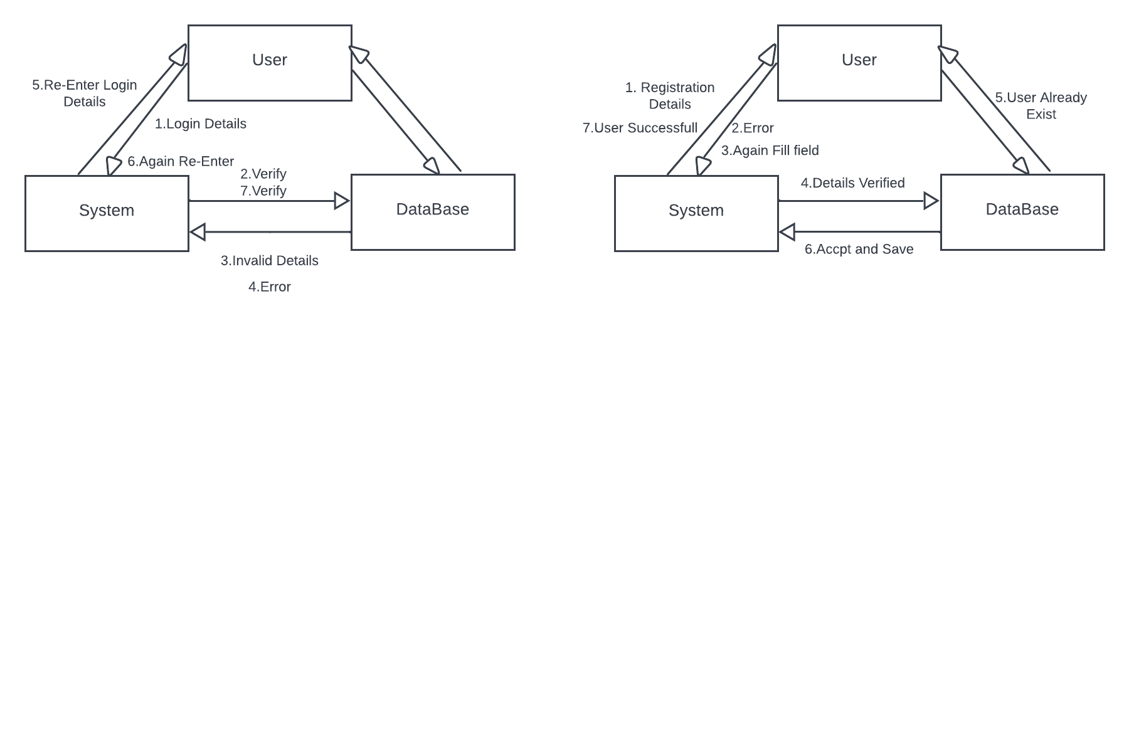
4.5.2 LOGIN
FIGURE: 4.5 COLLABORATION DIAGARM
4.6 DATA DICTIONARY

LOGIN TABLE

ATTRIBUTE NAME | DATATYPE | CONSTRAINTS | SAMPLE VALUES
UserName | Varchar(50) | Not null | Priya16
Password | Varchar(50) | Check | priya@12345

REGISTERATION

ATTRIBUTE NAME | DATATYPE | CONSTRAINTS | SAMPLE VALUES
E-mail id | Varchar(50) | Primary Key | priya@gmail.com
Name | Varchar(50) | Not Null | priya
Password | Varchar(50) | Check | Kirthi@12345
Conform Password | Varchar(50) | Check | Kirthi@12345

GROUP TABLE:

ATTRIBUTE NAME | DATATYPE | CONSTRAINTS | SAMPLE VALUES
Join Code | Number(20) | Check | 123456
Create Code | Number(20) | Check | 123456

5. CODING

Splash screen.xml

<?xml version="1.0" encoding="utf-8"?>
<RelativeLayout
android:layout_width="match_parent"
android:layout_height="match_parent"
android:background="#FFFFFF"
xmlns:android="http://schemas.android.com/apk/res/android"
xmlns:xmls="http://schemas.android.com/apk/res-auto">

<ImageView
android:id="@+id/logo"
android:layout_width="wrap_content"
android:layout_height="wrap_content"
android:layout_centerInParent="true"
android:src="@drawable/bjg"/>

<TextView
android:layout_width="fill_parent"
android:layout_height="wrap_content"
android:layout_marginBottom="10dp"
android:textSize="12dp"
android:textColor="#454545"
android:gravity="center_horizontal"
android:layout_alignParentBottom="true"
android:text="www.familytrackerapp.com"/>

</RelativeLayout>

Login.xml

<?xml version="1.0" encoding="utf-8"?>
<androidx.constraintlayout.widget.ConstraintLayout xmlns:android="http://schemas.android.com/apk/res/android"
xmlns:app="http://schemas.android.com/apk/res-auto"
xmlns:tools="http://schemas.android.com/tools"
android:layout_width="match_parent"
android:layout_height="match_parent"
android:background="@drawable/bb"
tools:context=".MainActivity">

<TextView
android:id="@+id/log
android:layout_width="wrap_content"
android:layout_height="wrap_content"
android:text="Login"
android:textColor="@color/colorWhite"
android:textSize="36sp"
android:textStyle="bold"
app:layout_constraintBottom_toBottomOf="parent"
app:layout_constraintEnd_toEndOf="parent"
app:layout_constraintStart_toStartOf="parent"
app:layout_constraintTop_toTopOf="parent"
app:layout_constraintVertical_bias="0.13" />

<EditText
android:id="@+id/inputPassword"
android:layout_width="0dp"
android:layout_height="wrap_content"
android:layout_marginTop="16dp"
android:background="@drawable/input_bg"
android:drawableLeft="@drawable/ic_person"
android:drawablePadding="10dp"
android:ems="10"
android:hint="Password"
android:inputType="textPersonName"
android:paddingLeft="20dp"
android:paddingTop="10dp"
android:paddingRight="10dp"
android:paddingBottom="10dp"
android:textColor="@color/colorWhite"
android:textColorHint="@color/colorWhite"
app:layout_constraintEnd_toEndOf="@+id/inputEmail"
app:layout_constraintHorizontal_bias="1.0"
app:layout_constraintStart_toStartOf="@+id/inputEmail"
app:layout_constraintTop_toBottomOf="@+id/inputEmail" />

<EditText
android:id="@+id/inputEmail"
android:layout_width="0dp"
android:layout_height="wrap_content"
android:layout_marginStart="32dp"
android:layout_marginTop="64dp"
android:layout_marginEnd="32dp"
android:background="@drawable/input_bg"
android:drawableLeft="@drawable/ic_email"

android:drawablePadding="10dp"
android:ems="10"
android:hint="Email"
android:inputType="textPersonName"
android:paddingLeft="20dp"
android:paddingTop="10dp"
android:paddingRight="10dp"
android:paddingBottom="10dp"
android:textColor="@color/colorWhite"
android:textColorHint="@color/colorWhite"
app:layout_constraintEnd_toEndOf="parent"
app:layout_constraintHorizontal_bias="0.0"
app:layout_constraintStart_toStartOf="parent"
app:layout_constraintTop_toBottomOf="@+id/logo" />

<TextView
android:id="@+id/forgotPassword"
android:layout_width="wrap_content"
android:layout_height="wrap_content"
android:layout_marginTop="16dp"
android:text="Forgot Password?"
android:textColor="@color/colorWhite"
android:textSize="18sp"
android:textStyle="bold"
app:layout_constraintEnd_toEndOf="@+id/inputPassword"
app:layout_constraintTop_toBottomOf="@+id/inputPassword" />

<Button
android:id="@+id/btnlogin"
android:layout_width="0dp"
android:layout_height="wrap_content"
android:layout_marginTop="24dp"
android:background="@drawable/btn_bg"
android:text="Login"
app:layout_constraintEnd_toEndOf="@+id/inputPassword"
app:layout_constraintStart_toStartOf="@+id/inputPassword"
app:layout_constraintTop_toBottomOf="@+id/forgotPassword" />

<LinearLayout
android:id="@+id/linearLayout"
android:layout_width="0dp"
android:layout_height="wrap_content"
android:layout_marginTop="16dp"
android:gravity="center"
android:orientation="horizontal"
android:textAlignment="center"
app:layout_constraintEnd_toEndOf="@+id/btnlogin"
app:layout_constraintHorizontal_bias="0.0"
app:layout_constraintStart_toStartOf="@+id/btnlogin"
app:layout_constraintTop_toBottomOf="@+id/btnlogin">

<TextView
android:layout_width="wrap_content"
android:layout_height="wrap_content"
android:text="Dont have an Account?"
android:textColor="@color/colorWhite" />

<TextView
android:id="@+id/textViewSignUp"
android:layout_width="wrap_content"
android:layout_height="wrap_content"
android:text="SignUp"
android:textColor="@color/colorRed" />

</LinearLayout>

<Button
android:id="@+id/btnGoogle"
android:layout_width="0dp"
android:layout_height="wrap_content"
android:layout_marginStart="32dp"
android:layout_marginEnd="8dp"
android:background="@drawable/btn_bg"
android:drawableLeft="@drawable/ic_google"
android:drawablePadding="10dp"
android:paddingLeft="20dp"
android:text="Google"
android:textAlignment="textStart"
android:textAllCaps="false"
app:layout_constraintBottom_toBottomOf="parent"
app:layout_constraintEnd_toStartOf="@+id/btnFacebook"
app:layout_constraintHorizontal_bias="0.5"
app:layout_constraintStart_toStartOf="parent"
app:layout_constraintTop_toBottomOf="@+id/linearLayout"
app:layout_constraintVertical_bias="0.32999998" />

<Button
android:id="@+id/btnFacebook"
android:layout_width="0dp"
android:layout_height="wrap_content"
android:layout_marginStart="8dp"
android:layout_marginEnd="32dp"
android:background="@drawable/btn_bg"
android:drawableStart="@drawable/ic_facebook"
android:drawablePadding="10dp"
android:paddingLeft="20dp"
android:text="Facebook"
android:textAlignment="textStart"
android:textAllCaps="false"
app:layout_constraintBottom_toBottomOf="@+id/btnGoogle"
app:layout_constraintEnd_toEndOf="parent"
app:layout_constraintHorizontal_bias="0.5"
app:layout_constraintStart_toEndOf="@+id/btnGoogle"
app:layout_constraintTop_toTopOf="@+id/btnGoogle" />

</androidx.constraintlayout.widget.ConstraintLayout>

Register.xml
<?xml version="1.0" encoding="utf-8"?>
<androidx.constraintlayout.widget.ConstraintLayout xmlns:android="http://schemas.android.com/apk/res/android"
xmlns:app="http://schemas.android.com/apk/res-auto"
xmlns:tools="http://schemas.android.com/tools"
android:layout_width="match_parent"
android:layout_height="match_parent"
tools:context=".register"
android:background="@drawable/bb">

<TextView
android:id="@+id/logo"
android:layout_width="wrap_content"
android:layout_height="wrap_content"
android:text="Register"
android:textColor="@color/colorWhite"
android:textSize="36sp"
android:textStyle="bold"
app:layout_constraintBottom_toBottomOf="parent"
app:layout_constraintEnd_toEndOf="parent"
app:layout_constraintStart_toStartOf="parent"
app:layout_constraintTop_toTopOf="parent"
app:layout_constraintVertical_bias="0.13" />

<EditText
android:id="@+id/inputUsername"
android:layout_width="0dp"
android:layout_height="wrap_content"
android:layout_marginStart="32dp"
android:layout_marginTop="40dp"
android:layout_marginEnd="32dp"
android:background="@drawable/input_bg"
android:drawableLeft="@drawable/ic_person"
android:drawablePadding="10dp"
android:ems="10"
android:hint="Username"
android:inputType="textPersonName"
android:paddingLeft="20dp"
android:paddingTop="10dp"
android:paddingRight="10dp"
android:paddingBottom="10dp"
android:textColor="@color/colorWhite"
android:textColorHint="@color/colorWhite"
app:layout_constraintEnd_toEndOf="parent"
app:layout_constraintStart_toStartOf="parent"
app:layout_constraintTop_toBottomOf="@+id/logo" />

<EditText
android:id="@+id/inputEmail"
android:layout_width="0dp"
android:layout_height="wrap_content"
android:layout_marginTop="16dp"
android:background="@drawable/input_bg"
android:drawableLeft="@drawable/ic_email"
android:drawablePadding="10dp"
android:ems="10"
android:hint="Email"
android:inputType="textPersonName"
android:paddingLeft="20dp"
android:paddingTop="10dp"
android:paddingRight="10dp"
android:paddingBottom="10dp"
android:textColor="@color/colorWhite"
android:textColorHint="@color/colorWhite"
app:layout_constraintEnd_toEndOf="@+id/inputUsername"
app:layout_constraintStart_toStartOf="@+id/inputUsername"
app:layout_constraintTop_toBottomOf="@+id/inputUsername" />

<EditText
android:id="@+id/inputPassword"
android:layout_width="0dp"
android:layout_height="wrap_content"
android:layout_marginTop="16dp"
android:background="@drawable/input_bg"
android:drawableLeft="@drawable/ic_security"
android:drawablePadding="10dp"
android:ems="10"
android:hint="******"
android:inputType="textPersonName"
android:paddingLeft="20dp"
android:paddingTop="10dp"
android:paddingRight="10dp"
android:paddingBottom="10dp"
android:textColor="@color/colorWhite"
android:textColorHint="@color/colorWhite"
app:layout_constraintEnd_toEndOf="@+id/inputEmail"
app:layout_constraintStart_toStartOf="@+id/inputEmail"
app:layout_constraintTop_toBottomOf="@+id/inputEmail" />

<EditText
android:id="@+id/inputConformPassword"
android:layout_width="0dp"
android:layout_height="wrap_content"
android:layout_marginTop="16dp"
android:background="@drawable/input_bg"
android:drawableLeft="@drawable/ic_security"
android:drawablePadding="10dp"
android:ems="10"
android:hint="******"
android:inputType="textPersonName"
android:paddingLeft="20dp"
android:paddingTop="10dp"
android:paddingRight="10dp"
android:paddingBottom="10dp"
android:textColor="@color/colorWhite"
android:textColorHint="@color/colorWhite"
app:layout_constraintEnd_toEndOf="@+id/inputPassword"
app:layout_constraintStart_toStartOf="@+id/inputPassword"
app:layout_constraintTop_toBottomOf="@+id/inputPassword" />

<Button
android:id="@+id/btnRegister"
android:layout_width="0dp"
android:layout_height="wrap_content"
android:layout_marginTop="24dp"
android:background="@drawable/btn_bg"
android:text="Register"
app:layout_constraintEnd_toEndOf="@+id/inputConformPassword"
app:layout_constraintStart_toStartOf="@+id/inputConformPassword"
app:layout_constraintTop_toBottomOf="@+id/inputConformPassword" />

<TextView
android:id="@+id/alreadyHaveAccount"
android:layout_width="wrap_content"
android:layout_height="wrap_content"
android:layout_marginTop="16dp"
android:shadowColor="@color/colorWhite"
android:text="Already Have an Account?"
android:textColor="@color/colorWhite"
app:layout_constraintEnd_toEndOf="@+id/btnRegister"
app:layout_constraintStart_toStartOf="@+id/btnRegister"
app:layout_constraintTop_toBottomOf="@+id/btnRegister" />
</androidx.constraintlayout.widget.ConstraintLayout>

Home.xml
<?xml version="1.0" encoding="utf-8"?>
<RelativeLayout xmlns:android="http://schemas.android.com/apk/res/android"
xmlns:app="http://schemas.android.com/apk/res-auto"
xmlns:tools="http://schemas.android.com/tools"
android:layout_width="match_parent"
android:layout_height="match_parent"
android:background="@drawable/bb"
tools:context=".home">

<Button
android:id="@+id/join"
android:layout_width="wrap_content"
android:layout_height="wrap_content"
android:layout_alignParentStart="true"
android:layout_alignParentTop="true"
android:layout_alignParentEnd="true"
android:layout_marginStart="75dp"
android:layout_marginLeft="1dp"
android:layout_marginTop="269dp"
android:layout_marginEnd="75dp"
android:background="@drawable/btn_bg"
android:text="JOIN GROUP"
tools:layout_editor_absoluteX="131dp"
tools:layout_editor_absoluteY="98dp" />

<Button
android:id="@+id/create"
android:layout_width="wrap_content"
android:layout_height="wrap_content"
android:layout_alignParentStart="true"
android:layout_alignParentTop="true"
android:layout_alignParentEnd="true"
android:layout_marginStart="75dp"
android:layout_marginLeft="1dp"
android:layout_marginTop="345dp"
android:layout_marginEnd="75dp"
android:background="@drawable/btn_bg"
android:text="CREATE GROUP"
tools:layout_editor_absoluteX="131dp"
tools:layout_editor_absoluteY="98dp" />

<Button
android:id="@+id/button2"
android:layout_width="wrap_content"
android:layout_height="wrap_content"
android:layout_alignParentStart="true"
android:layout_alignParentTop="true"
android:layout_alignParentEnd="true"
android:layout_marginStart="75dp"
android:layout_marginLeft="1dp"
android:layout_marginTop="419dp"
android:layout_marginEnd="75dp"
android:background="@drawable/btn_bg"
android:text="TRACK LOCATION"
tools:layout_editor_absoluteX="131dp"
tools:layout_editor_absoluteY="98dp" />

</RelativeLayout>

Joingp.xml

<?xml version="1.0" encoding="utf-8"?>
<RelativeLayout xmlns:android="http://schemas.android.com/apk/res/android"
xmlns:app="http://schemas.android.com/apk/res-auto"
xmlns:tools="http://schemas.android.com/tools"
android:layout_width="match_parent"
android:layout_height="match_parent"
android:background="@drawable/bb"
tools:context=".joingp">

<EditText
android:id="@+id/jcode"
android:layout_width="wrap_content"
android:layout_height="wrap_content"
android:layout_alignParentTop="true"
android:layout_centerHorizontal="true"
android:layout_marginTop="250dp"
android:ems="10"
android:hint="Unique Code"
android:inputType="textPersonName"
android:textColorHint="@color/colorWhite"
android:backgroundTint="@color/colorWhite"
android:textColor="@color/colorWhite"/>

<Button
android:id="@id/join"
android:layout_width="wrap_content"
android:layout_height="wrap_content"
android:layout_below="@+id/jcode"
android:layout_alignParentStart="true"
android:layout_alignParentTop="true"
android:layout_alignParentEnd="true"
android:layout_centerHorizontal="true"
android:layout_marginStart="74dp"
android:layout_marginLeft="1dp"
android:layout_marginTop="378dp"
android:layout_marginEnd="76dp"
android:background="@drawable/btn_bg"
android:text="JOIN GROUP"
tools:layout_editor_absoluteX="131dp"
tools:layout_editor_absoluteY="98dp" />
</RelativeLayout>

Creategp.xml

<?xml version="1.0" encoding="utf-8"?>
<RelativeLayout xmlns:android="http://schemas.android.com/apk/res/android"
xmlns:app="http://schemas.android.com/apk/res-auto"
xmlns:tools="http://schemas.android.com/tools"
android:layout_width="match_parent"
android:layout_height="match_parent"
android:background="@drawable/bb"
tools:context=".creategp">

<EditText
android:id="@+id/jcode"
android:layout_width="wrap_content"
android:layout_height="wrap_content"
android:layout_alignParentTop="true"
android:layout_centerHorizontal="true"
android:layout_marginTop="250dp"
android:ems="10"
android:hint="Create Unique Code"
android:inputType="textPersonName"
android:textColorHint="@color/colorWhite"
android:backgroundTint="@color/colorWhite"
android:textColor="@color/colorWhite"/>

<Button
android:id="@+id/create"
android:layout_width="wrap_content"
android:layout_height="wrap_content"
android:layout_below="@+id/jcode"
android:layout_alignParentStart="true"
android:layout_alignParentTop="true"
android:layout_alignParentEnd="true"
android:layout_centerHorizontal="true"
android:layout_marginStart="74dp"
android:layout_marginLeft="1dp"
android:layout_marginTop="378dp"
android:layout_marginEnd="76dp"
android:background="@drawable/btn_bg"
android:text="CREATE GROUP"
tools:layout_editor_absoluteX="131dp"
tools:layout_editor_absoluteY="98dp" />
</RelativeLayout>

Main.xml

<?xml version="1.0" encoding="utf-8"?>
<LinearLayout xmlns:android="http://schemas.android.com/apk/res/android"
xmlns:app="http://schemas.android.com/apk/res-auto"
xmlns:tools="http://schemas.android.com/tools"
android:layout_width="match_parent"
android:layout_height="match_parent"
android:orientation="vertical"
android:padding="10dp"
tools:context=".Mainscreen">

<EditText
android:id="@+id/et_input"
android:layout_width="match_parent"
android:layout_height="wrap_content"
android:hint="Enter Text Here"/>

<Button
android:id="@+id/bt_save"
android:layout_width="match_parent"
android:layout_height="wrap_content"
android:hint="Save"/>

<ListView
android:id="@+id/listView"
android:layout_width="match_parent"
android:layout_height="wrap_content"
android:dividerHeight="10dp"
android:divider="@color/colorAccent"/>
</LinearLayout>

Splash Screen.java

package com.example.firstpage;
import androidx.appcompat.app.AppCompatActivity;

import android.content.Intent;
import android.os.Bundle;
import android.os.Handler;
import android.window.SplashScreen;

public class splash_screen extends AppCompatActivity {

@Override
protected void onCreate(Bundle savedInstanceState) {
super.onCreate(savedInstanceState);
setContentView(R.layout.activity_splash_screen);

new Handler().postDelayed(new Runnable() {
@Override
public void run() {
Intent intent = new Intent(splash_screen.this,MainActivity.class);
startActivity(intent);
}
},5000);
}
}
Login.java

package com.example.firstpage;
import androidx.annotation.NonNull;
import androidx.appcompat.app.AppCompatActivity;

import android.app.ProgressDialog;
import android.os.Bundle;
import android.content.Intent;
import android.view.View;
import android.widget.Button;
import android.widget.EditText;
import android.widget.ProgressBar;
import android.widget.TextView;
import android.widget.Toast;

import com.google.android.gms.tasks.OnCompleteListener;
import com.google.android.gms.tasks.Task;
import com.google.firebase.auth.AuthResult;
import com.google.firebase.auth.FirebaseAuth;

public class MainActivity extends AppCompatActivity {
TextView btn;
EditText inputEmail,inputPassword;
Button btnlogin;
private FirebaseAuth mAuth;
ProgressDialog mLoadingBar;
@Override
protected void onCreate(Bundle savedInstanceState) {
super.onCreate(savedInstanceState);
setContentView(R.layout.activity_main);

btn=findViewById(R.id.textViewSignUp);
inputEmail=findViewById(R.id.inputEmail);
inputPassword=findViewById(R.id.inputPassword);
btnlogin=findViewById(R.id.btnlogin);
mAuth=FirebaseAuth.getInstance();
mLoadingBar=new ProgressDialog(MainActivity.this);

btnlogin.setOnClickListener(new View.OnClickListener() {
@Override
public void onClick(View view) {
checkCrededentials();
}
});
btn.setOnClickListener(new View.OnClickListener() {
@Override
public void onClick(View v) {
startActivity(new Intent(MainActivity.this,register.class));
}
});
}

private void checkCrededentials() {

String email = inputEmail.getText().toString();
String password = inputPassword.getText().toString();

if (email.isEmpty()) {
showError(inputEmail, "Email is not valid");
} else if (password.isEmpty() || password.length() < 7) {
showError(inputPassword, "Password must be 7 characters");
} else {
mLoadingBar.setTitle("Login");
mLoadingBar.setMessage("Please wait,While check your credentials");
mLoadingBar.setCanceledOnTouchOutside(false);
mLoadingBar.show();

mAuth.signInWithEmailAndPassword(email, password).addOnCompleteListener(new OnCompleteListener<AuthResult>() {
@Override
public void onComplete(@NonNull Task<AuthResult> task) {
if (task.isSuccessful()) {

Intent intent = new Intent(MainActivity.this, home.class);
intent.setFlags(Intent.FLAG_ACTIVITY_CLEAR_TASK | Intent.FLAG_ACTIVITY_NEW_TASK);
startActivity(intent);
mLoadingBar.dismiss();
}
}
});
}
}
private void showError(EditText input,String s)
{
input.setError(s);
input.requestFocus();

}
}
Register.java

package com.example.firstpage;

import androidx.annotation.NonNull;
import androidx.appcompat.app.AppCompatActivity;

import android.app.ProgressDialog;
import android.content.Intent;
import android.os.Bundle;
import android.view.View;
import android.widget.Button;
import android.widget.EditText;
import android.widget.ProgressBar;
import android.widget.TextView;
import android.widget.Toast;

import com.google.android.gms.tasks.OnCompleteListener;
import com.google.android.gms.tasks.Task;
import com.google.firebase.auth.AuthResult;
import com.google.firebase.auth.FirebaseAuth;

public class register extends AppCompatActivity {
TextView btn;

private EditText inputUsername,inputPassword,inputConformPassword,inputEmail;
Button btnRegister;
private FirebaseAuth mAuth;
private ProgressDialog mLoadingBar;

@Override
protected void onCreate(Bundle savedInstanceState) {
super.onCreate(savedInstanceState);
setContentView(R.layout.activity_register);

btn=findViewById(R.id.alreadyHaveAccount);
inputUsername=findViewById(R.id.inputUsername);
inputPassword=findViewById(R.id.inputPassword);
inputConformPassword=findViewById(R.id.inputConformPassword);
inputEmail=findViewById(R.id.inputEmail);
mAuth=FirebaseAuth.getInstance();
mLoadingBar=new ProgressDialog(register.this);

btnRegister=findViewById(R.id.btnRegister);

btnRegister.setOnClickListener(new View.OnClickListener() {
@Override
public void onClick(View view) {
checkCrededentials();
}
});
btn.setOnClickListener(new View.OnClickListener() {
@Override
public void onClick(View v) {
startActivity(new Intent(register.this, MainActivity.class));
}
});
}

private void checkCrededentials() {
String username=inputUsername.getText().toString();
String email=inputEmail.getText().toString();
String password=inputPassword.getText().toString();
String conformPassword=inputConformPassword.getText().toString();

if(username.isEmpty() || username.length()<7)
{
showError(inputUsername,"your username is not valid!");
}
else if(email.isEmpty())
{
showError(inputEmail,"Email is not valid");
}
else if(password.isEmpty() || password.length()<7)
{
showError(inputPassword,"Password must be 7 characters");
}
else if(conformPassword.isEmpty() || !conformPassword.equals(password))
{
showError(inputConformPassword,"Password not match!");
}
else
{
mLoadingBar.setTitle("Registeration");
mLoadingBar.setMessage("Please wait,While check your credentials");
mLoadingBar.setCanceledOnTouchOutside(false);
mLoadingBar.show();

mAuth.createUserWithEmailAndPassword(email,password).addOnCompleteListener(new OnCompleteListener<AuthResult>() {
@Override
public void onComplete(@NonNull Task<AuthResult> task) {
if(task.isSuccessful()){
Toast.makeText(register.this,"Successfully Registered",Toast.LENGTH_SHORT).show();

Intent intent=new Intent(register.this,MainActivity.class);
intent.setFlags(Intent.FLAG_ACTIVITY_CLEAR_TASK|Intent.FLAG_ACTIVITY_NEW_TASK);
startActivity(intent);
mLoadingBar.dismiss();
}
else{
Toast.makeText(register.this,task.getException().toString(),Toast.LENGTH_SHORT).show();
}
}
});
}

}

private void showError(EditText input, String s) {
input.setError(s);
input.requestFocus();
}
}

Home.java

package com.example.firstpage;

import androidx.appcompat.app.AppCompatActivity;

import android.content.Intent;
import android.os.Bundle;
import android.view.View;
import android.widget.Button;
import androidx.appcompat.app.AppCompatActivity;
public class home extends AppCompatActivity {
private Button join,create;

@Override
protected void onCreate(Bundle savedInstanceState) {
super.onCreate(savedInstanceState);
setContentView(R.layout.activity_home);
join=findViewById(R.id.join);
create=findViewById(R.id.create);
join.setOnClickListener(new View.OnClickListener() {
@Override
public void onClick(View v){
Intent intent=new Intent(home.this,joingp.class);
startActivity(intent);
}
});

create.setOnClickListener(new View.OnClickListener() {
@Override
public void onClick(View v){
Intent intent=new Intent(home.this,creategp.class);
startActivity(intent);
}
});

}
}

Joingp.java

package com.example.firstpage;

import android.content.Intent;
import android.os.Bundle;

import android.util.Log;
import android.view.View;
import android.widget.Button;
import android.widget.EditText;
import android.widget.Toast;

import androidx.appcompat.app.AppCompatActivity;

import com.google.firebase.auth.FirebaseAuth;
import com.google.firebase.auth.FirebaseUser;
import com.google.firebase.database.DataSnapshot;
import com.google.firebase.database.DatabaseError;
import com.google.firebase.database.DatabaseReference;
import com.google.firebase.database.FirebaseDatabase;
import com.google.firebase.database.ValueEventListener;

import java.util.HashMap;
import java.util.Map;

public class joingp extends AppCompatActivity {

FirebaseAuth mAuth;
EditText jcode;
Button join;
String uname="";

@Override
protected void onCreate(Bundle savedInstanceState) {
super.onCreate(savedInstanceState);
setContentView(R.layout.activity_joingp);

jcode = (EditText)findViewById(R.id.jcode);
join = (Button)findViewById(R.id.join);
mAuth = FirebaseAuth.getInstance();
FirebaseUser firebaseUser = mAuth.getCurrentUser();
final String uid = firebaseUser.getUid();
Log.d("blabla","Hry");

final DatabaseReference userInfo = FirebaseDatabase.getInstance().getReference().child("Users").child(uid).child("Name");
userInfo.addListenerForSingleValueEvent(new ValueEventListener() {
@Override
public void onDataChange(DataSnapshot dataSnapshot) {
uname = dataSnapshot.getValue().toString();
Log.d("Updated","Hry");
Toast.makeText(getApplicationContext(),uname,Toast.LENGTH_SHORT).show();
}

@Override
public void onCancelled(DatabaseError databaseError) {

}
});

join.setOnClickListener(new View.OnClickListener() {
@Override
public void onClick(View v) {
String code = jcode.getText().toString();

DatabaseReference jRef = FirebaseDatabase.getInstance().getReference().child("Groups").child(code).child(uid);
Map newUser = new HashMap();
newUser.put("Name",uname);

jRef.setValue(newUser);

DatabaseReference groupRef = FirebaseDatabase.getInstance().getReference().child("Users").child(uid);
groupRef.child("Group").setValue(code);

Intent intent = new Intent(joingp.this, Mainscreen.class);
startActivity(intent);

Toast.makeText(getApplicationContext(),"Group Joined",Toast.LENGTH_SHORT).show();
}
});
}

@Override
public void onBackPressed() {
super.onBackPressed();
}
}

Creategp.java

package com.example.firstpage;

import android.content.Intent;
import android.os.Bundle;

import android.util.Log;
import android.view.View;
import android.widget.Button;
import android.widget.EditText;
import android.widget.Toast;

import androidx.appcompat.app.AppCompatActivity;

import com.google.firebase.auth.FirebaseAuth;
import com.google.firebase.auth.FirebaseUser;
import com.google.firebase.database.DataSnapshot;
import com.google.firebase.database.DatabaseError;
import com.google.firebase.database.DatabaseReference;
import com.google.firebase.database.FirebaseDatabase;
import com.google.firebase.database.ValueEventListener;

import java.util.HashMap;
import java.util.Map;

public class creategp extends AppCompatActivity {
private FirebaseAuth mAuth;
private FirebaseAuth.AuthStateListener mAuthStateListner;
private Button create;
private EditText mcode;
String uname="";

@Override
protected void onCreate(Bundle savedInstanceState) {
super.onCreate(savedInstanceState);
setContentView(R.layout.activity_creategp);

mAuth = FirebaseAuth.getInstance();
create =(Button)findViewById(R.id.create);
mcode = (EditText) findViewById(R.id.jcode);
FirebaseUser firebaseUser = mAuth.getCurrentUser();
final String uid = firebaseUser.getUid();

final DatabaseReference userInfo = FirebaseDatabase.getInstance().getReference().child("Users").child(uid).child("Name");
userInfo.addListenerForSingleValueEvent(new ValueEventListener() {
@Override
public void onDataChange(DataSnapshot dataSnapshot) {
uname = dataSnapshot.getValue().toString();
Log.d("Updated","Hry");
Toast.makeText(getApplicationContext(),uname,Toast.LENGTH_SHORT).show();
}

@Override
public void onCancelled(DatabaseError databaseError) {

}
});

create.setOnClickListener(new View.OnClickListener() {
@Override
public void onClick(View v) {
String code = mcode.getText().toString();

DatabaseReference mRef = FirebaseDatabase.getInstance().getReference().child("Groups").child(code).child(uid);
Map newPost = new HashMap();

newPost.put("Name",uname);

mRef.setValue(newPost);

DatabaseReference groupRef = FirebaseDatabase.getInstance().getReference().child("Users").child(uid);
groupRef.child("Group").setValue(code);

Intent intent = new Intent(creategp.this, Mainscreen.class);
startActivity(intent);

Toast.makeText(getApplicationContext(),"Group Created",Toast.LENGTH_SHORT).show();

}

});
}

@Override
public void onBackPressed() {
super.onBackPressed();
}
}

Main.java
package com.example.firstpage;
import android.os.Bundle;
import android.view.View;
import android.widget.ArrayAdapter;
import android.widget.Button;
import android.widget.EditText;
import android.widget.ListView;

import androidx.appcompat.app.AppCompatActivity;

import java.util.ArrayList;

public class Mainscreen extends AppCompatActivity {
ArrayList<String> listitems=new ArrayList<>();
ArrayAdapter<String> adapter;
@Override
protected void onCreate(Bundle savedInstanceState){
super.onCreate(savedInstanceState);
setContentView(R.layout.activity_mainscreen);

EditText input=findViewById(R.id.et_input);
Button Save=findViewById(R.id.bt_save);
ListView listView=findViewById(R.id.listView);

adapter=new ArrayAdapter<String>(this,android.R.layout.simple_list_item_1,listitems);
listView.setAdapter(adapter);

Save.setOnClickListener(new View.OnClickListener(){
@Override
public void onClick(View v){
listitems.add(input.getText().toString());
adapter.notifyDataSetChanged();
input.setText("");
}
});
}

}

6. TESTING

SYSTEM TESTING

Testing is a set of activities that can be planned in advance and conducted systematically. The proposed system is tested in parallel with the software that consists of its own phases of analysis, implementation, testing and maintenance. Following are the tests conducted on the system.

UNIT TESTING:

During the implementation of the system each module of the system was tested separately to uncover errors with in its boundaries. User interface was used as a guide in the process.

MODULE TESTING

A module is composed of various programs related to that module. Module testing is done to check the module functionality and interaction between units within a module. It checks the functionality of each program with relation to other programs within the same module. It then tests the overall functionality of each module.

INTEGRATION TESTING

Integration testing is a systematic technique for constructing the program structure while conducting tests to uncover errors associated with interfacing. The objective is to take unit-tested module and build a program structures that has been dictated by design.

ACCEPTANCE TESTING

The software has been tested with the realistic data given by the client and produced fruitful results. The client satisfying all the requirements specified by them has also developed the software within the time limitation specified. A demonstration has been given to the client and the end-user giving all the operational features.

IMPLEMENTATION PHASE

The implementation is the final and important phase. It involves user training, system testing and successful running of the developed system. The users test the developed system when changes are made according to the needs. The testing phase involves the testing of the developed system using various kinds of data. An elaborate testing of data is prepared and system is tested using the tests data.

Implementation is the stage where theoretical design turned into a working system. Implementation is planed carefully to propose system to avoid unanticipated problems. Many preparations involved before and during the implementation of proposed system. The system needed to be plugged in to the organization’s network then it could be accessed from anywhere, after a user logins into the portal. The tasks that had to be done to implement the system were to create the database tables in the organization database domain. Then the administrator was granted his role so that the system could be accessed. The next phase in the implementation was to educate the system.

7 .OUTPUT SCREENS

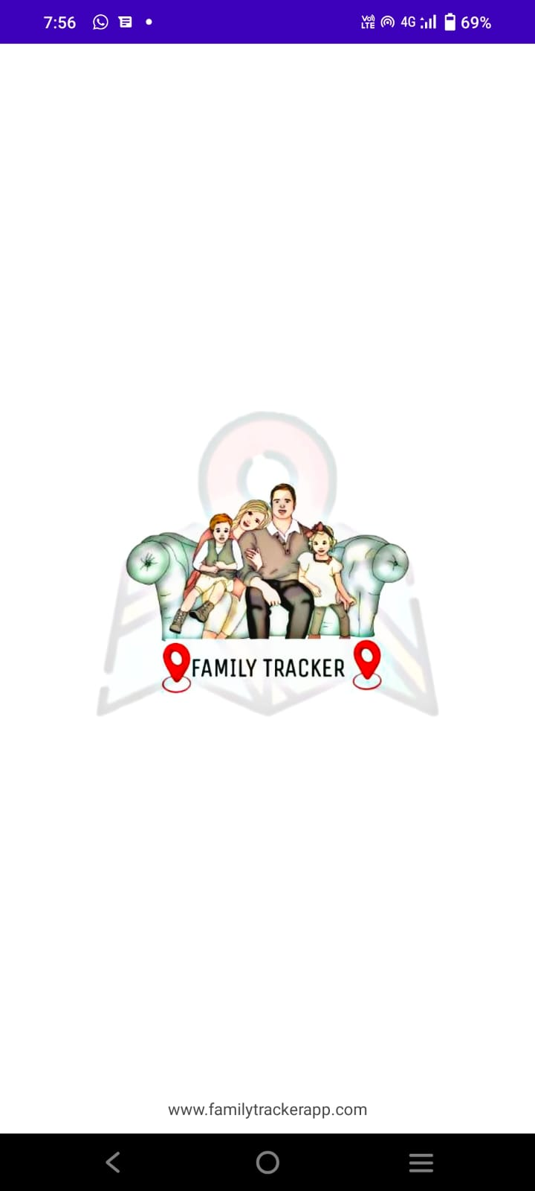

FIGURE: SPLASH SCREEN

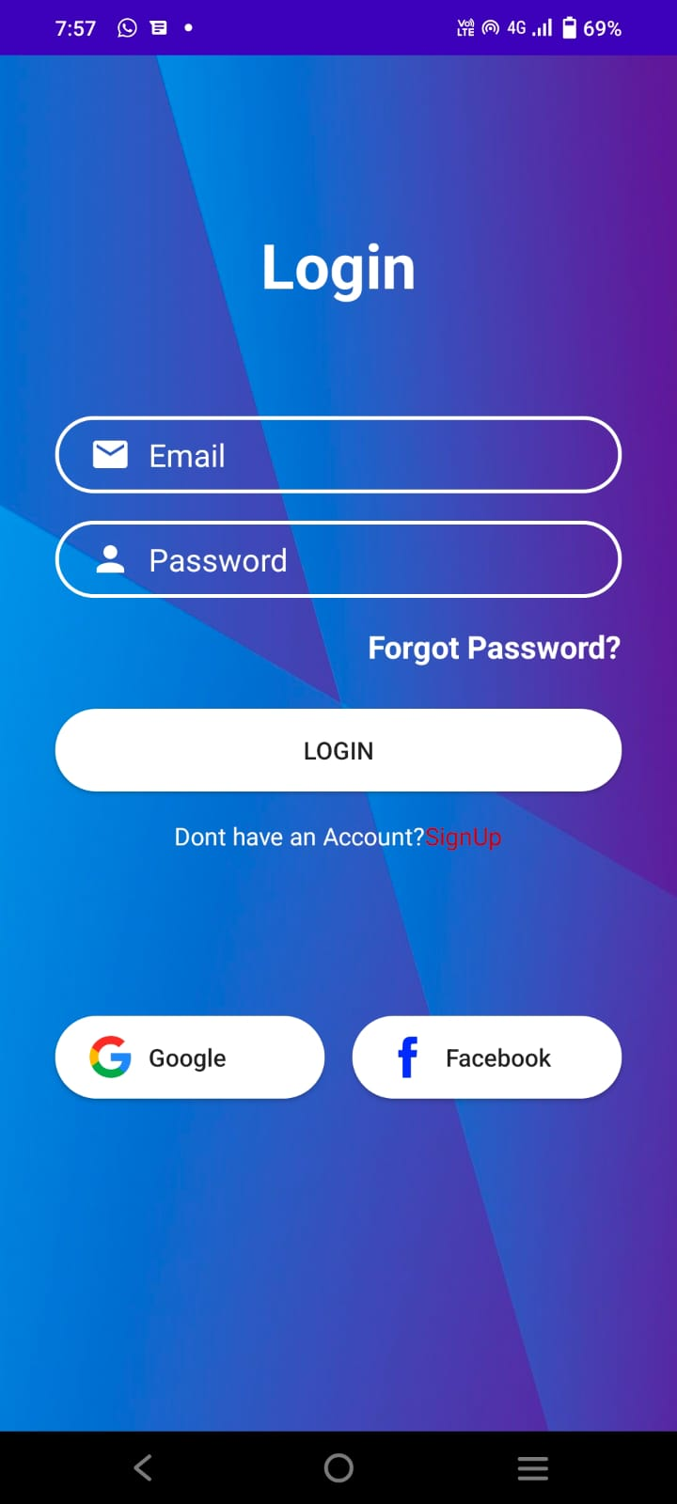

FIGURE: LOGIN PAGE

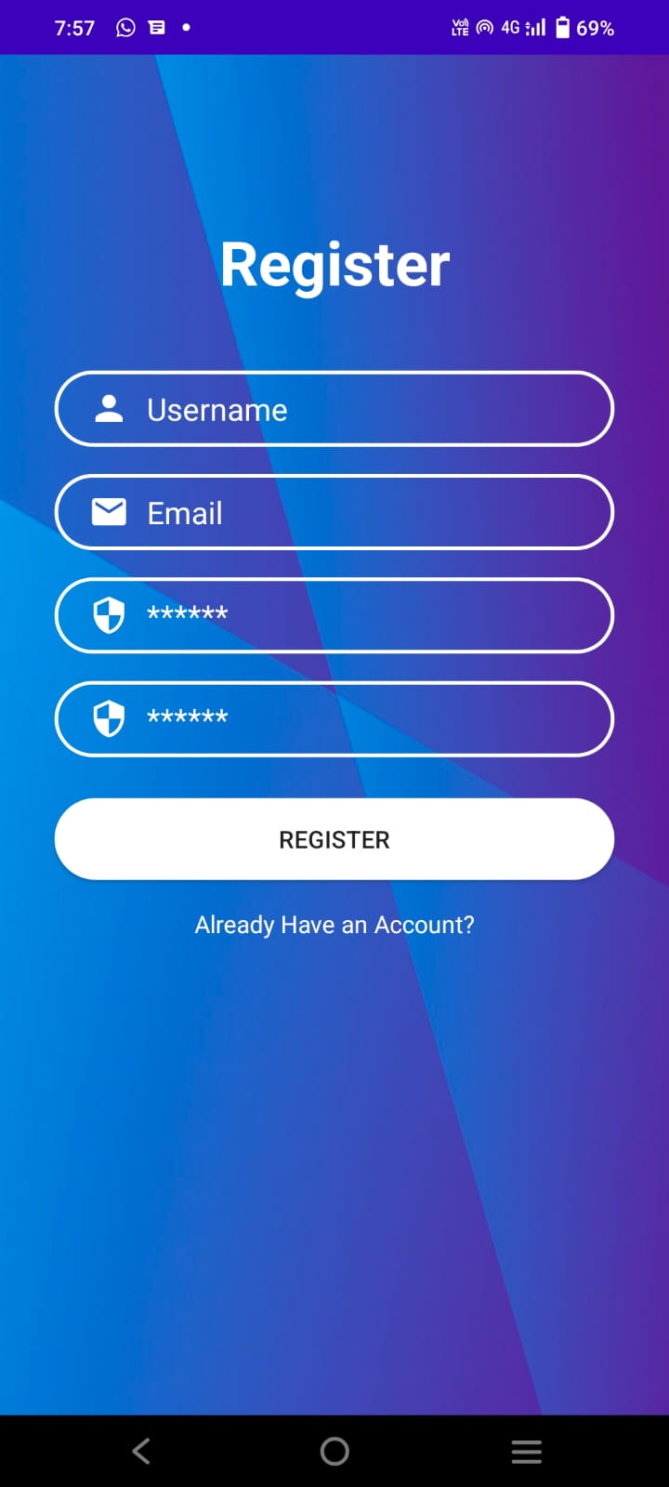

FIGURE: REGISTERATION

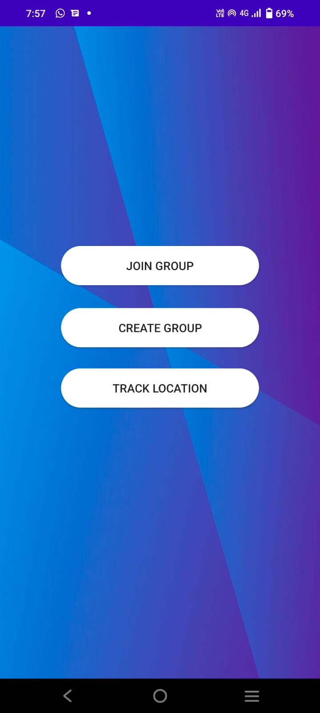

FIGURE: HOME PAGE

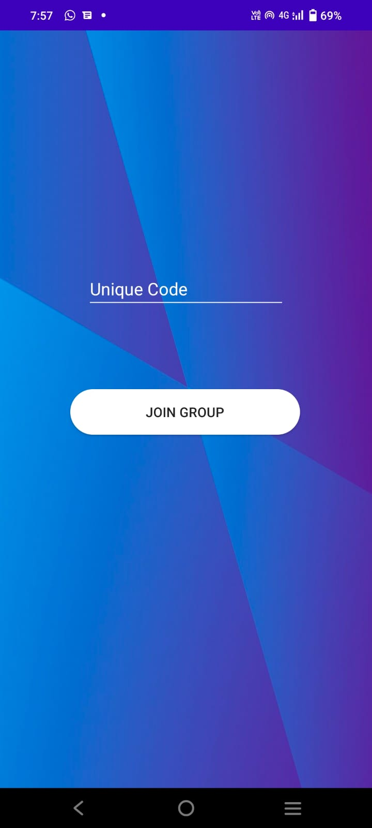

FIGURE: JOIN GROUP

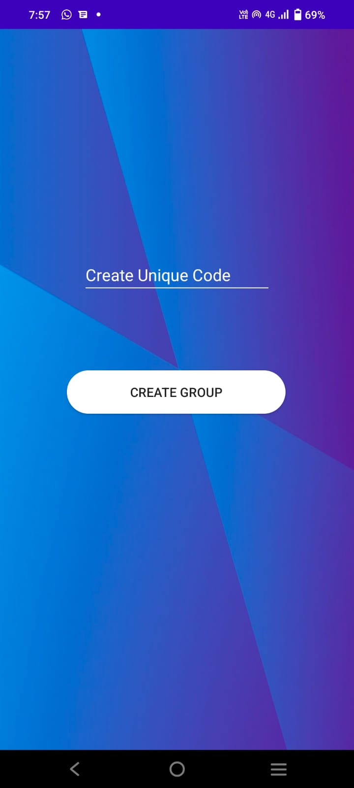

FIGURE: CREATE GROUP

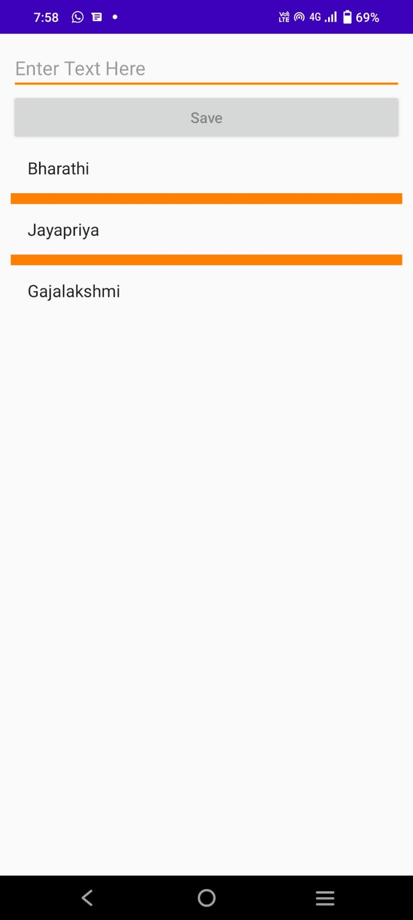

FIGURE: MEMBERS LIST

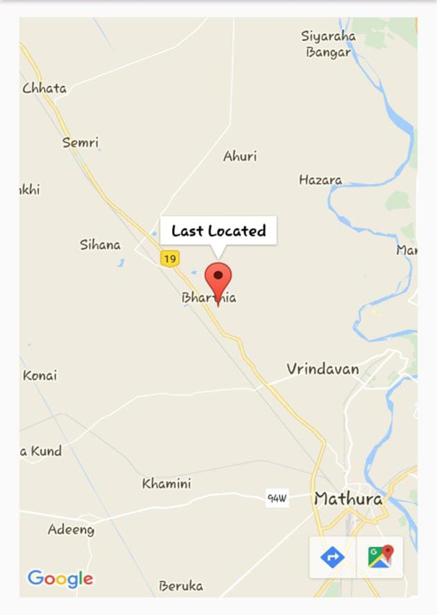

FIGURE: TRACK LOCATION

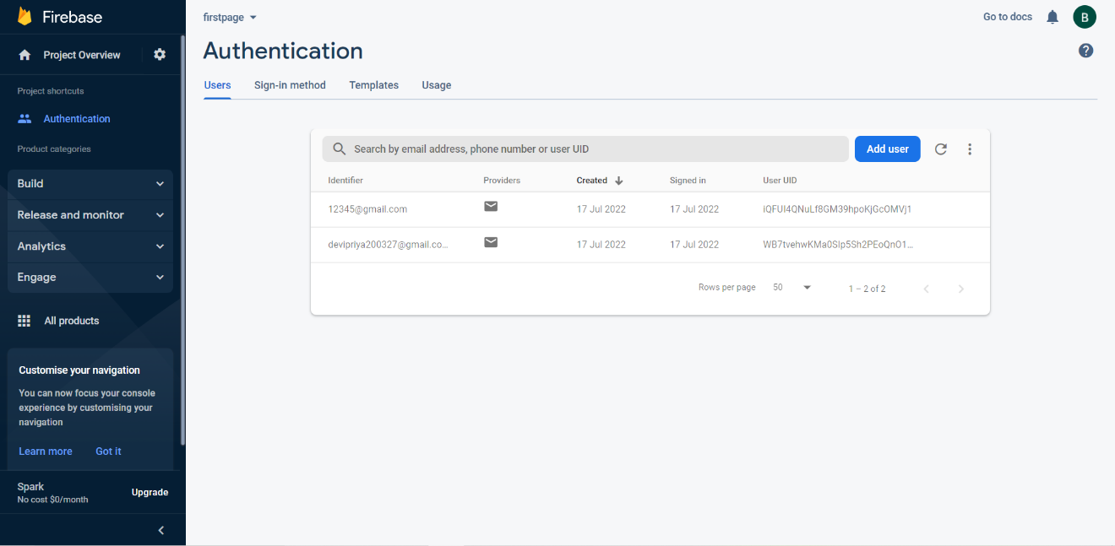

FIGURE: FIREBASE

8. CONCLUSION

It has been a great pleasure for me to work on this exciting project. This project proved good for me as it provided practical knowledge of programming in JAVA and Firebase Console, but also about all handling procedure related with “FAMILY TRACKER APPLICATION USING GPS”. Online system has been developed as the best flexible and efficient project within the available resource and time. As the online sector computerized day to day, to connect with human and to keep in touch. This project will provide better opportunities and guidance in future to develop projects independently.

The Internet has become a major factor in today’s world, thus this app will prove helpful not only to the User, but also to the external user who is going to register.

Getting accurate information about location you need is an important part of preparing for a locating friends and family. Thus we have provided an app that can useful in any way.

REFERENCE

1.G. O. Young, “Synthetic structure of industrial plastics (Book style with paper title and editor),” in Plastics, 2nd ed. vol. 3, J. Peters, Ed. New York: McGraw-Hill, 1964.
https://techterms.com/definition/gps
2.W.-K. Chen, Linear Networks and Systems (Book style). Belmont, CA: Wadsworth, 1993.https://glympse.com/get-glympse-app/
3.H. Poor, An Introduction to Signal Detection and Estimation. New York: Springer-Verlag, 1985. https://techterms.com/definition/gps
4.B. Smith, “An approach to graphs of linear forms (Unpublished work style),”unpublished. https://blog.hubstaff.com/gps-tracker-app-options/
5.E. H. Miller, “A note on reflector arrays (Periodical style—Accepted for publication),” IEEE Trans. Antennas Propagat., to be published.
https://www.macworld.com/article/2883251/how-to-share-your-location-with-ios-8-without-creeping-yourself-out.html
6.J. Wang, “Fundamentals of erbium-doped fiber amplifiers arrays (Periodical style—Submitted for publication),” IEEE J. Quantum Electron., submitted for publication.
https://patents.google.com/patent/US20060085813A1/en
7.C. J. Kaufman, Rocky Mountain Research Lab., Boulder, CO, private communication, May 1995.
https://www.google.com/maps/@4.140634,109.6181485,6z

APPENDIX

LOCATION TRACKING REQUIREMENTS :

Mobile phone tracking is a process for identifying the location of a mobile phone, whether stationary or moving. Localization may occur either via multilateration of radio signals between (several) cell towers of the network and the phone, or simply via GPS. To locate a mobile phone using multilateration of radio signals, it must emit at least the roaming signal to contact the next nearby antenna tower, but the process does not require an active call. The Global System for Mobile Communications (GSM) is based on the phone's signal strength to nearby antenna masts.

GPS base location tracker is an application with GPS services which would help in locating Geography position of people in the single entity of largest communities depends on their current location. Geography position would be displayed on the map view on our android set such as Google Maps,Nokia Maps,iOS Map Services. All users, location would be retrieved from online database so as to control the permission for viewing. Periodic refreshing has to be present so that each time the geo–location changes or after a fixed interval of time the values in the database should be updated. All devices would be having a unique ID (UID) and this would be used for searching for the user.

GLOBAL POSITIONING SYSTEM:

Stands for "Global Positioning System." GPS is a satellite navigation system used to determine the ground position of an object. The Global Positioning System (GPS) was established in 1973 by United States Department of Defence, it uses to tracking works via a network of satellites in orbit to determine the location user and time through the device. In order for a GPS device to work correctly, it must first establish a connection to the required number of satellites. This process can take anywhere from a few seconds to a few minutes, depending on the strength of the receiver. For example, a car's GPS unit will typically establish a GPS connection faster than the receiver in a watch or smartphone. Most GPS devices also use some type of location caching to speed up GPS detection. By memorizing its previous location, a GPS device can quickly determine what satellites will be available the next time it scans for a GPS signal.
Triangulation by multiple satellites locates the device, making GPS become the most accurate method for finding locations. However, drawbacks include the
lack of user-accessible GPS capabilities in most personal cell phones and the scarce availability of built-in 11 GPS technology in commercial laptops. Additionally, GPS can be battery intensive and inconsistent or unavailable indoors

LOCATION BASED SERVICES(LBS) :

LBS are a software application that used concepts of knowledge. The concept applied by using a mobile device which it can locate user everyware. location-based service (LBS) is a software application for a IP-capable mobile device that requires knowledge about where the mobile device is located. Location-based services can be query-based and provide the end user with useful information such as "Where is the nearest ATM?" or they can be push-based and deliver coupons or other marketing information to customers who are in a specific geographical area. There are many services provided by LBS such as health, work, personal life, etc. it can adapt with various facilities.

ANDROID:

Android is a mobile operating system (OS) first developed by a Silicon Valley company by the name of Android Inc. A collaboration spearheaded by Google in 2007 through the Open Handset Alliance (OHA) gave Android an edge in delivering a complete software set, which includes the main OS, middleware and specific mobile application, or app. Android also a complete set of the software for mobile devices includes operating systems, device software, middleware (middleware), and The main user application (e-mail client, calendar, maps, browser, contacts, etc.). Android has the most of its code under Apache License, free software and open source license. Android helps developers to build an application by using android.
Java Language and Dalvik virtual machine with compilation on execution time. However, android have advantage and limitation too. Features on Android among others are:
- Framework application, it could recycling and substitution component.

b) Integrated browser-based engine Open Source WebKit is also used in the iPhone browser and Nokia S60v3.

- The design of the handset. Platform tailored to the needs VGA (Video Graphics Adapter) more large library of 2D and 3D graphics based on specifications OpenGL ES 1.0 as well as the layout a traditional smartphone.

- Multi-touch. Android has native support for multi-touch available on the latest handsets.

- Support for additional hardware. Android support camera, touch screen, GPS (Global Positioning System), measuring speed, magnetometer, acceleration 2D bit blits (with orientation hardware, scaling, format conversion pixels) and 3D graphics acceleration.

GOOGLE MAP :

In this paper [21] discuss the Google Maps launched in 2005 has revolutionized online mapping service applications on the World Wide Web. Based on Asynchronous JavaScript and XML (AJAX), a new type of client/server interaction was introduced in Google Maps to maintain a continuous connection between the client and the server for immediate downloading of additional map information . In addition, Google also provides programmers its extensive sources of code called the Application Programming Interface (API). The API consists of a set of data structures, object classes or functions that can be used by a programmer using Javascript,PHP or another scripting language.

ANDROID STUDIO :

In this paper [20] discuss Android Studio is the official integrated development environment (IDE) for Android application development. It is based on the IntelliJ IDEA, a Java integrated development environment for software, and incorporates its code editing and developer tools.

To support application development within the Android operating system, Android Studio uses a Gradle-based build system, emulator, code templates, and Github integration. Every project in Android Studio has one or more modalities with source code and resource files. These modalities include Android app modules, Library modules, and Google App Engine modules.

Android Studio uses an Instant Push feature to push code and resource changes to a running application. A code editor assists the developer with writing code and offering code completion, refraction, and analysis. Applications built in Android Studio are then compiled into the APK format for submission to the Google Play Store. The software was first announced at Google I/O in May 2013, and the first stable build was released in December 2014. Android Studio is available for Mac, Windows, and Linux desktop platforms. It replaced Eclipse Android Development Tools (ADT) as the primary IDE for Android application development. Android Studio and the Software Development Kit can be downloaded directly from Google.

